**COFFEE SHOP SALES PROJECT – MYSQL WORKBENCH**

The raw data (excel) is imported into SQL, leveraging order by, group by, alter, modify, count, sum, over for structured insights.

The database coffee is created.

The table ‘sql power bi project - coffee` is created and values are imported into the table.

This query describe `sql power bi project - coffee`; is used to retrive the key information about a table’s structure,

select * from `sql power bi project - coffee` is used to view the entire table.

**SQL QUERIES:**

Create database coffee;

use coffee;

create table `sql power bi project - coffee`;

describe `sql power bi project - coffee`;

select * from `sql power bi project - coffee`

**Update – to modify or change the existing records in a table, Convert date (transaction_date) column into proper date format:**

update `sql power bi project - coffee`

Set transaction_date = str_to_date (transaction_date, '%d-%m-%Y');

**Alter date (transaction_date) column to date data type:**

alter table `sql power bi project - coffee`

modify column transaction_date date;

describe`sql power bi project - coffee`;

**Convert time (transaction_time) column to proper time format:**

update `sql power bi project - coffee`

set transaction_time = str_to_date(transaction_time, '%H:%i:%s');

**Alter time (transaction_time) column to proper time format:**

alter table `sql power bi project - coffee`

modify column transaction_time time;

select * from `sql power bi project - coffee`

**Change column name ï»¿transaction_id TO transaction_id:**

ALTER TABLE `sql power bi project - coffee`

RENAME COLUMN ï»¿transaction_id TO transaction_id;

**Describe – Datatypes of different column:**

describe `sql power bi project - coffee`

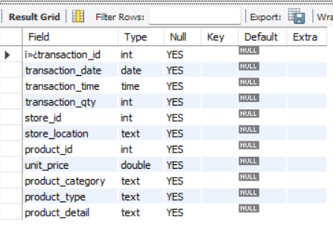

1. **Total Sales Analysis:**

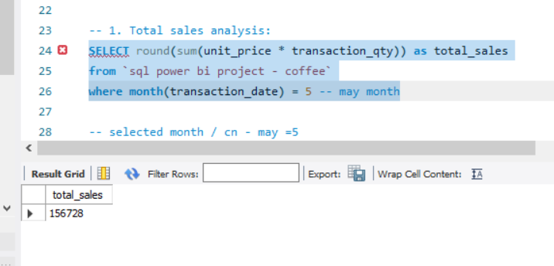

**-- selected month / current month - may =5**

**-- previous month = april =4**

Select

month(transaction_date) AS month, -- number of month

round(Sum(unit_price * transaction_qty)) AS total_sales, -- total sales column

(sum(unit_price * transaction_qty) - lag(sum(unit_price * transaction_qty), 1) -- month sales difference

over (Order by month(transaction_date))) / lag(sum(unit_price * transaction_qty), 1) -- division by previous sales

over (Order by month(transaction_date)) * 100 as mom_increase_percentage -- convert into percentage

from `sql power bi project - coffee`

where month(transaction_date) in (4, 5) -- for months of April (pre) and May (curr)

group by month(transaction_date)

order by month(transaction_date);

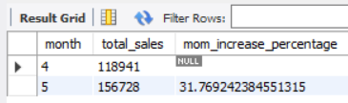

**2)Total orders analysis:**

select count(transaction_id) as Total_Orders

from `sql power bi project - coffee`

where month (transaction_date)= 5 -- for month of (CM-May)

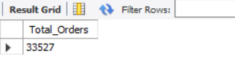

**-- month on month increase or decrease**

select

month(transaction_date) as month,

round(count(transaction_id)) as total_orders,

(count(transaction_id) - lag(count(transaction_id), 1)

over (order by month(transaction_date))) / lag(count(transaction_id), 1)

over (order by month(transaction_date)) * 100 as mom_increase_percentage

from `sql power bi project - coffee`

where month(transaction_date) IN (4, 5) -- for April and May

group by month(transaction_date)

order by month(transaction_date);

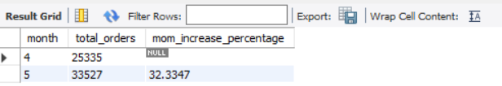

**3) Total quantity sold analysis:**

select sum(transaction_qty) as Total_Quantity_Sold

from `sql power bi project - coffee`

where month(transaction_date) = 5 -- for month of (CM-May)

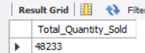

**-- month on month incresae and difference:**

select month (transaction_date) as month,

round(sum(transaction_qty)) as total_quantity_sold,

(sum(transaction_qty) - lag(sum(transaction_qty), 1)

over (order by month(transaction_date))) / lag(sum(transaction_qty), 1)

over (order by month(transaction_date)) * 100 as mom_increase_percentage

from `sql power bi project - coffee`

where month(transaction_date) in (4, 5) -- for April and May

group by month(transaction_date)

order by month(transaction_date);

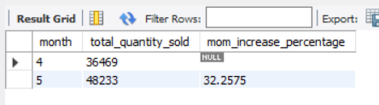

**4)Calender heat map:**

select concat(round(SUM(unit_price * transaction_qty)/1000,1), 'k') as total_sales,

concat(round(SUM(transaction_qty)/1000,1), 'k') as total_quantity_sold,

concat(round(COUNT(transaction_id)/1000,1), 'k') as total_orders

from `sql power bi project - coffee`

where transaction_date = '2023-05-18'; -- for 18 May 2023

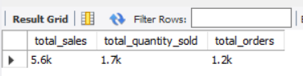

**5)Sales analysis by weekdays and weekends:**

select

case when dayofweek(transaction_date) in (1,7) then 'weekends'

else 'weekdays'

end as day_type,

concat(round(sum(unit_price * transaction_qty)/1000,1), 'k') as total_sales

from `sql power bi project - coffee`

where month(transaction_date) = 5 -- may month

group by

case when dayofweek(transaction_date) in (1,7) then 'weekends'

else 'weekdays'

end

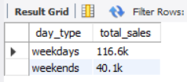

**6)Sales analysis by store location:**

SELECT store_location,

concat(round(SUM(unit_price * transaction_qty)/1000,1), 'k') as Total_Sales

from `sql power bi project - coffee`

where month (transaction_date) =5 -- may

group by store_location

order by sum(unit_price * transaction_qty) DESC

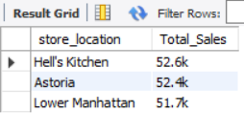

**7)Daily sales analysis with average line:**

select

concat(round(avg(total_sales)/1000,1), 'k') as avg_sales

from

(

select sum(transaction_qty * unit_price) as total_sales

from `sql power bi project - coffee`

where month(transaction_date)=4

group by transaction_date

) as internal_query

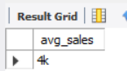

select

day(transaction_date) as day_of_month,

round(sum(unit_price * transaction_qty),1) as total_sales

from `sql power bi project - coffee`

where month(transaction_date) = 5 --filter for May

group by day(transaction_date)

order by day(transaction_date);

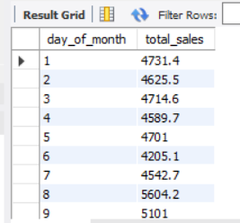

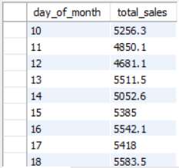

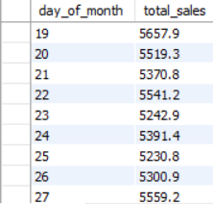

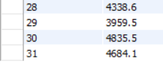

select day_of_month,

case

when total_sales > avg_sales then 'Above Average'

when total_sales < avg_sales then 'Below Average'

else 'equal to Average'

end as sales_status,

total_sales

from (

select

day(transaction_date) as day_of_month,

sum(unit_price * transaction_qty) as total_sales,

avg(sum(unit_price * transaction_qty)) over () as avg_sales

from `sql power bi project - coffee`

where month(transaction_date) = 5 -- filter for May

group by day(transaction_date)

) as sales_data

order by day_of_month;

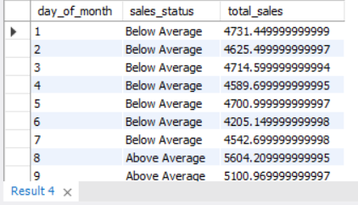

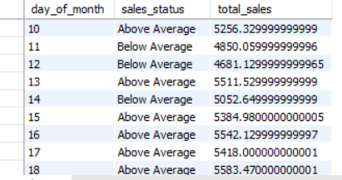

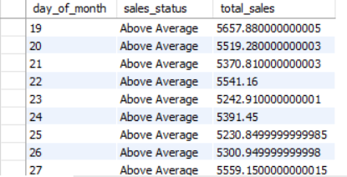

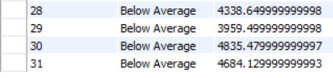

**8) Sales by product category:**

select product_category,

sum(unit_price * transaction_qty) as total_sales

from `sql power bi project - coffee`

where month(transaction_date) = 5

group by product_category

order by sum(unit_price * transaction_qty)desc

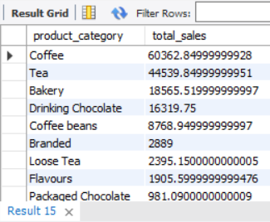

**9)Top 10 products by sales:**

select product_type, round(sum(unit_price * transaction_qty),1) as Total_Sales

from `sql power bi project - coffee`

where month(transaction_date) = 5 and product_category = 'coffee'

group by product_type

order by sum(unit_price * transaction_qty) desc

limit 10

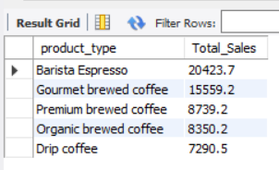

**10) Sales Analysis by days and hours:**

select

round(sum(unit_price * transaction_qty)) as Total_Sales,

sum(transaction_qty) as Total_Quantity,

count(*) as Total_Orders

from `sql power bi project - coffee`

where dayofweek(transaction_date) = 3 -- filter for Tuesday (1 is Sunday, 2 is Monday, ..., 7 is Saturday)

and hour(transaction_time) = 8 -- filter for hour number 8

and month(transaction_date) = 5; -- filter for May (month number 5)

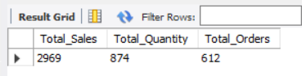

**11) Hour of transaction time:**

select hour(transaction_time),

sum(unit_price * transaction_qty) as total_sales

from `sql power bi project - coffee`

where month(transaction_date)=5

group by hour (transaction_time)

order by hour(transaction_time)

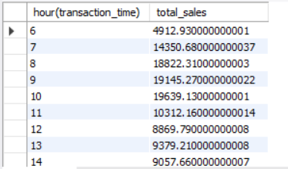

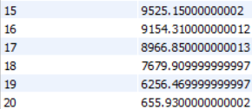

--**To get sales from Monday to Sunday for month of may:**

select

case

when dayofweek(transaction_date) = 2 then 'Monday'

when dayofweek(transaction_date) = 3 then 'Tuesday'

when dayofweek(transaction_date) = 4 then 'Wednesday'

when dayofweek(transaction_date) = 5 then 'Thursday'

when dayofweek(transaction_date) = 6 then 'Friday'

when dayofweek(transaction_date) = 7 then 'Saturday'

else 'Sunday'

end as Day_of_Week,

round(sum(unit_price * transaction_qty)) as Total_Sales

from `sql power bi project - coffee`

where month(transaction_date) = 5 -- Filter for May (month number 5)

group by

case

when dayofweek(transaction_date) = 2 then 'Monday'

when dayofweek(transaction_date) = 3 then 'Tuesday'

when dayofweek(transaction_date) = 4 then 'Wednesday'

when dayofweek(transaction_date) = 5 then 'Thursday'

when dayofweek(transaction_date) = 6 then 'Friday'

when dayofweek(transaction_date) = 7 then 'Saturday'

else 'Sunday'

end;

